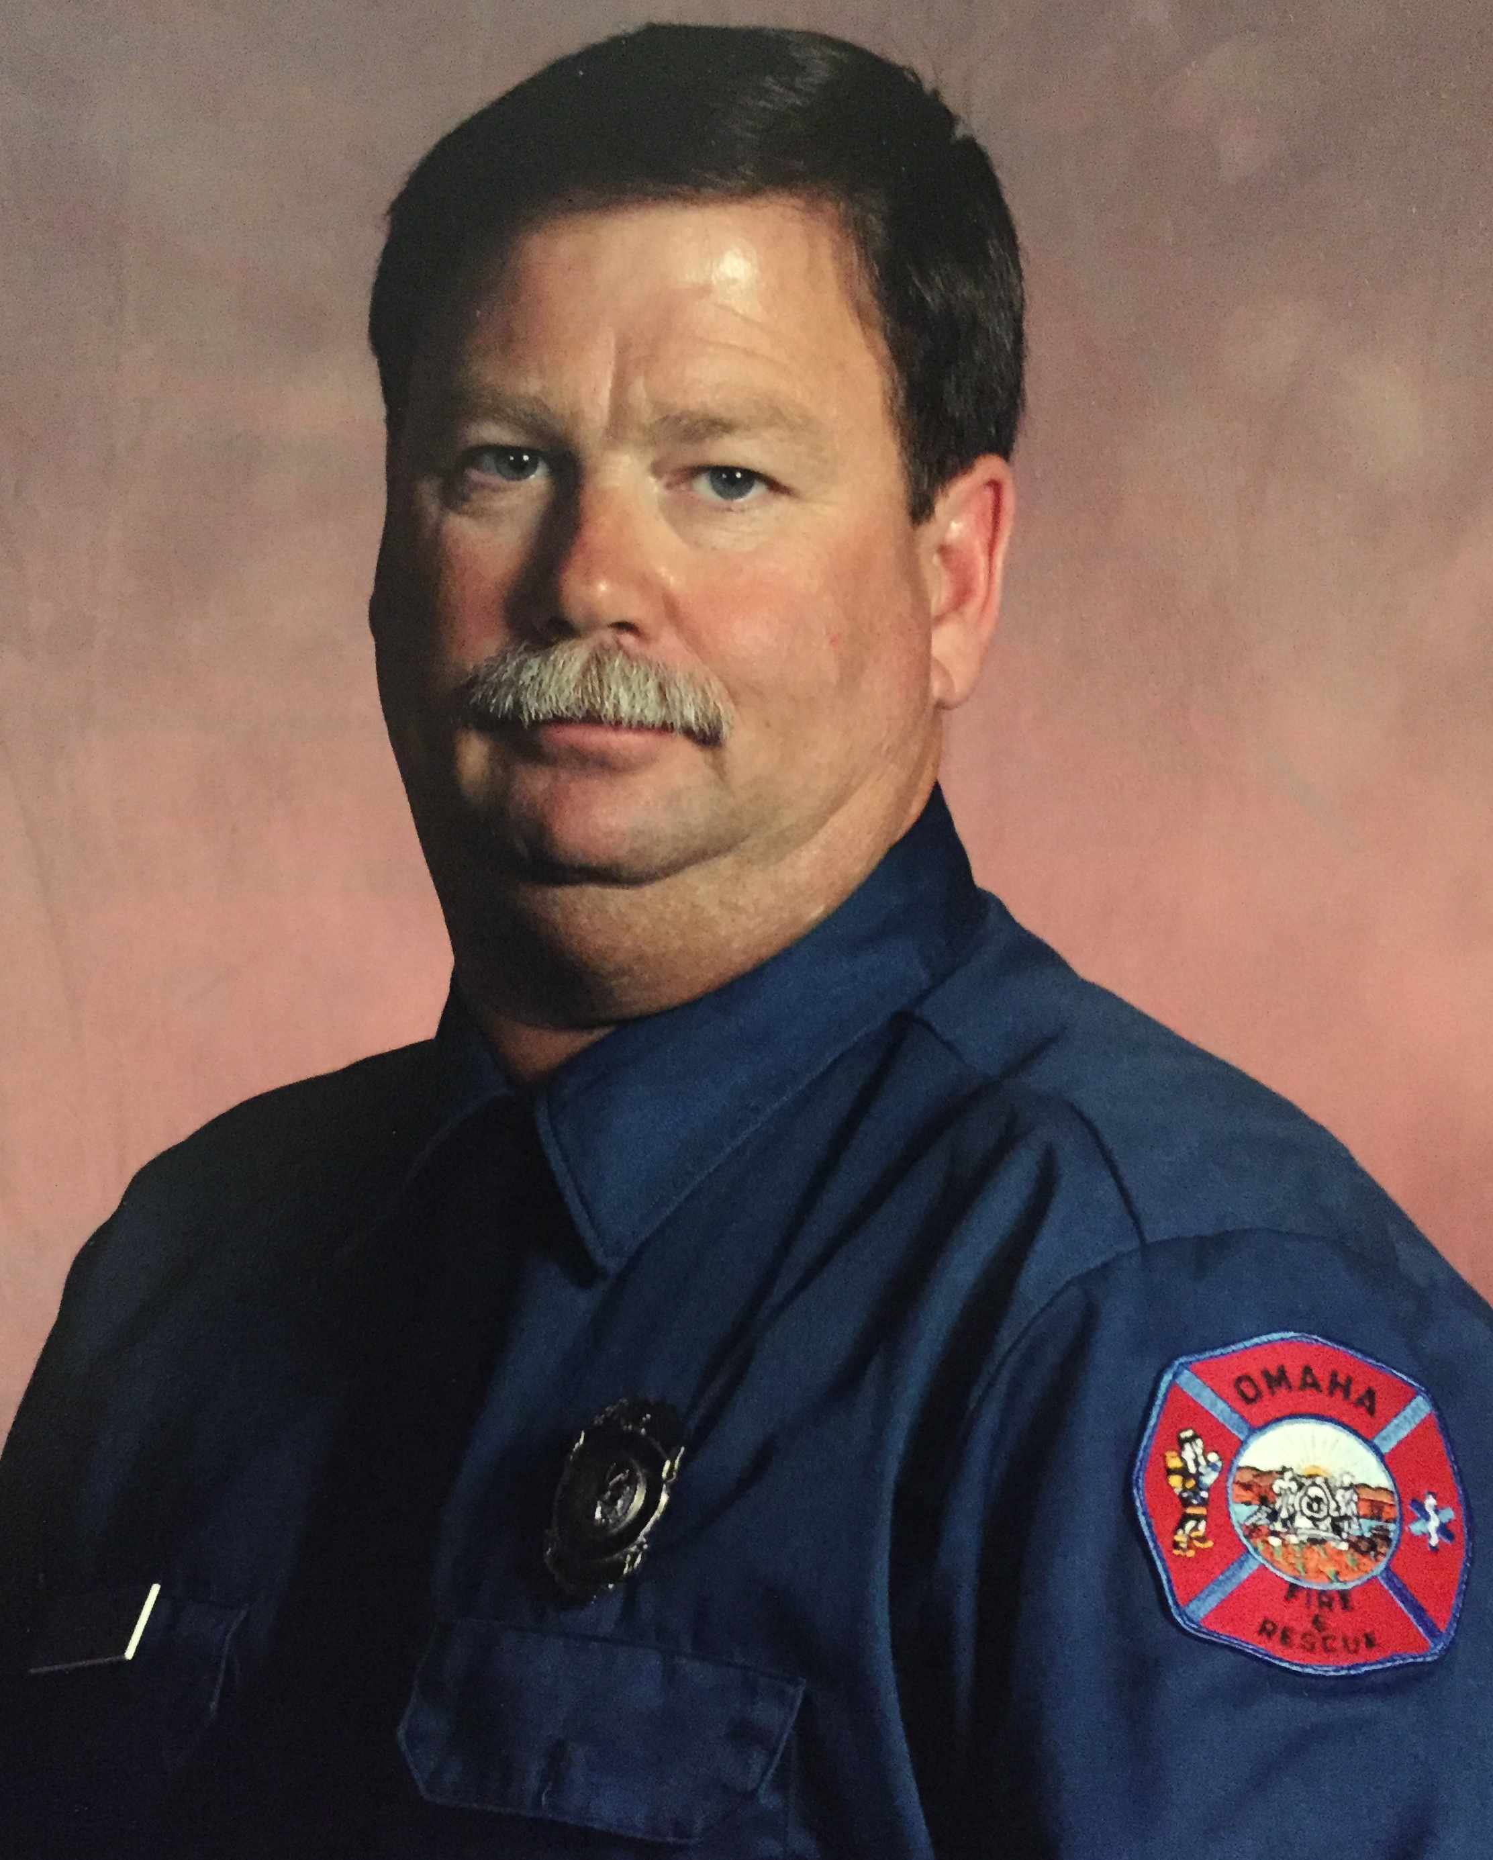

J.R. Christiansen (Vice President)
Community service has been the focus of my career. During my four years on the board, I have helped transition the HOA from a cash deficit to a substantial surplus. Going forward, my goals are to maintain and improve our pool and park area and keep our neighborhood safe and friendly in order to attract people to live in our neighborhood.

- Harrison Woods HOA President since 2010
- Paid firefighter for the Omaha/Millard Fire Departments (30 years)
- Harrison Woods Action Team 2007-2010
- Harrison Woods HOA member 2010-present
- My wife Sherry has 2 grown children and 8 grandchildren.
- My volunteer involvement in the community includes: Millard Days Committee (25 years served, president for last 16 years), Gretna Rural Fire District Tax Board (6 years), Harrison Woods SID Board Trustee(6 years), Past Board Member Lakeview Heights SID Board Trustee (4 years)
- My hobbies include: spending time with grandchildren, golfing, boating, and cooking.


Maurice Anderson (Vice President)
I became a member of the Harrison Woods Board of Directors in 2010 when the homeowners association transitioned from NP Dodge to the residents. My initial and continuing goal is to assist with making Harrison Woods the best neighborhood in the city to reside. In my opinion, this includes improvement of the pool and park area as well as the walking trail. I also believe promotion of neighborhood activities builds a strong sense of community. These visions lead to my involvement with the Harrison Woods SID Board, which I continue to serve on thanks to the support of the neighborhood. My intention is to continue working to improve our neighborhood based on a consensus of the residents while ensuring we remain financially responsible.

- Harrison Woods HOA Secretary 2010 to 8/2014
- Harrison Woods HOA Vice President 8/2014 to Present
- Harrison Woods SID President 2012 to Present
- Professionally, Owner and operator of Anderson Claim Service
- CYSL Soccer League Incoming President 12/2014
- St Stephen the Martyr Soccer Club Co-President 8/2013 to Present
- Technical Director St Stephen the Martyr annual Musical
- My exceptional spouse, Kim, and I have 3 daughters ages 15 to 9.
- Our involvements with their various academic and sporting interests keep us busy along with chasing Suri, our 2 year old Wheaton Terrier. Our entire family is also involved with various activities at our Church, St Stephen the Martyr.

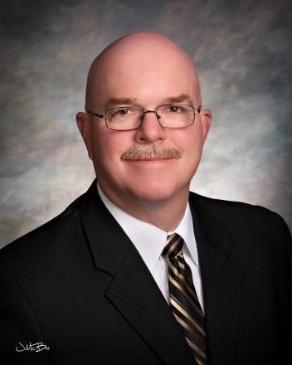

David Chezem (Treasurer)
As a member of the Harrison Woods Board of Directors my goal is to make our neighborhood inviting to all who live and visit here. I believe our neighborhood should present itself as a place of peace & comfort to all! I will work with fellow Board members to progress, neighbor approved, projects and maintain our property, in a financially responsible manner. I believe each family in the neighborhood should have an opportunity to have their voice be heard. It is my goal to listen intently and take action accordingly.

- Harrison Woods Board Member since 8/2012
- My wife Ruby & I have 5 children and eight grandchildren.
- Owner/Operator of an American Family Insurance Agency since June of 1989.
- Coached youth sports and sat on the Football Board at Millard Athletic Association 2006 to 2014.
- Belong to a local Sertoma (Service to Mankind) club raising funds to benefit the hearing impaired in the Omaha & Nebraska area
- My wife & I enjoy spending time with our children, and are active in our grandchildren’s school, athletic, and musical activities.
- Hobbies include golf, attending local college & high school sporting events with my children & grandchildren, community involvement and traveling with my wife.

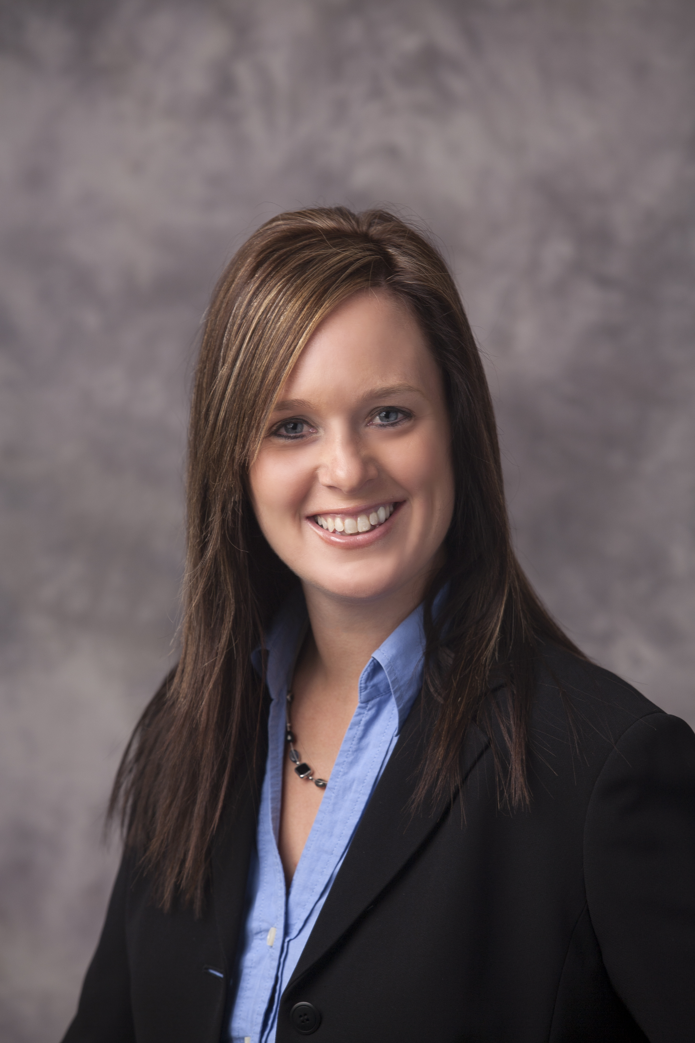

Stephanie Magnussen (Secretary)
As a Harrison Woods board member my goal is to foster an inclusive sense of community through: involving and informing neighbors of community activities, maintaining an updated and aesthetically pleasing webpage, using technology to streamline and make processes more efficient, and maintain a fun and family friendly neighborhood!
- Harrison Woods Board Member since 8/2014
- My husband, Chris and I have 3 sons and 1 daughter. Nathan (13), Aden (8) and Madden (5) and Morgan (1).
- Senior Database Manager at TD Ameritrade
- I enjoy being active with my children through school involvement, athletics, neighborhood socials, and volunteering time within our community for organizations such as Habitat for Humanity and the YES house.
- My hobbies include baking, reading, watching baseball, reality television, and most importantly spending time with friends and family!
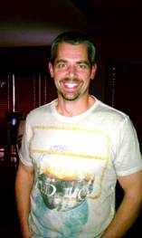

Bruce Krause (Board Member)
As a Harrison Woods board member my goal is to encourage a sense of community by means of social activities and direct homeowner input into the growth of our neighborhood!
- Harrison Woods Board Member since 8/2014
- I have a daughter, Honest (7), in second grade at Palisades Elementary.
- Senior Software Developer for Fiserv
- I stay active in my community through school involvement, Girl Scouts (yes, we will be by with the cookies), neighborhood socials, volunteering time and the gift of life at the American Red Cross, running in various charity races, and spending as much time as possible at the Harrison Woods Pool!
- My hobbies include running, biking, making craft beer, scuba diving, and snow skiing.

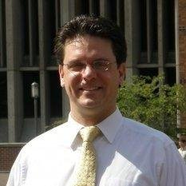

Ryan Whitt (Board Member)
As a Harrison Woods board member my goal is to move projects forward that will continue to make Harrison Woods an amazing community. The primary initiative is to develop a new pool and park area. The pool and park space was a main reason why we moved here and I want to see this area continue to be a wonderful neighborhood focal point for years to come. The first priority for any HOA is fiscal stability of the neighborhood. The second is to bring the neighborhood together as a community. The board has succeeded in attaining and maintaining the first priority. It is now time to move initiatives forward such as the pool and park, as well as several others to bring this community closer.
- Harrison Woods Board Member since 8/2014
- My wife, Jean, and I have 1 son and 3 daughters. Andrew (19), Natalie (17), Amelia (8) and Abigail (5), as well as 1 Cocker Spaniel (Jazz), 1 Piranha, 2 Koi and 3 Gold Fish.
- Principal Bank Knowledge Consultant at WhittGroup. Current full-time assignment within Product Development at D3 Banking, a financial technology company. Professionally, I excel at accelerating start-up companies as they go to market.
- I enjoy the incredible seasons of Nebraska with my family by being active with outdoor activities, local attractions, and community events. We volunteer through our involvement with the Henry Doorly Zoo, Voices for Children, Girl Scouts of America and I a personally sit on the board and/or committees of various not-for-profit organizations.
- Hobbies include cooking and creating new stuff, reading, scuba diving, motorcycles, sports cars, learning anything new, and spending time with friends and family.


George Chezem (Board Member)
As a Harrison Woods board member my goal is to keep this community thriving!
- Harrison Woods Board Member since 2012

